Pizza Sales SQL queries

- KPI’s

- Total Revenue: The sum of total price of pizzas orders.
SELECT SUM(total_price) AS Total_Revenue FROM pizza_sales;
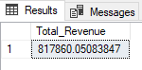
- Average Order Value: The average amount spent per order, calculated by dividing the total number of orders.
SELECT SUM (total_price) / COUNT (DISTINCT order_id) AS Average_Order_Values FROM pizza_sales;
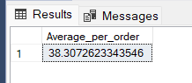

- Total Pizzas Sold: The total sum of quantities of all pizzas sold.
SELECT SUM(quantity) AS Total_Pizza_sold FROM pizza_sales
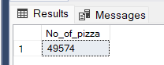

- Total Orders Placed: The count of all the orders placed by the customers.
SELECT COUNT(DISTINCT order_id) AS Total_Orders FROM pizza_sales 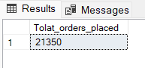

- Average Pizzas per Order: The average numbers of pizzas sold per order, calculated by dividing the total numbers of pizzas sold by the total number of orders.
SELECT CAST(CAST(SUM(quantity) AS DECIMAL (10,2))/CAST(COUNT(DISTINCT order_id) AS DECIMAL (10,2))AS DECIMAL (10,2)) AS Avg_Pizzas_per_Order FROM pizza_sales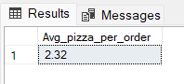

B. Daily trend for Total orders:
1. Create a bar chart that displays the daily trend of total orders over a specific time period. This chart will help us to identify any patterns or fluctuations in the order volume on a daily basis.
SELECT DATENAME(DW, order_date) as Order_days, COUNT(DISTINCT order_id) AS Total_orders
FROM pizza_sales
GROUP BY DATENAME(DW, order_date)
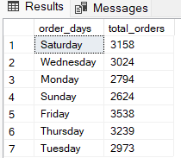

** Total orders arranged with respect to Days from Sunday to Saturday
SELECT DATENAME(DW, order_date) as Order_days, COUNT(DISTINCT order_id) as Total_orders
FROM pizza_sales
GROUP BY DATENAME(DW, order_date)
ORDER BY CASE WHEN DATENAME(DW, order_date) = 'Sunday' then 1
WHEN DATENAME(DW, order_date) = 'Monday' then 2
WHEN DATENAME(DW, order_date) = 'Tuesday' then 3
WHEN DATENAME(DW, order_date) = 'Wednesday' then 4
WHEN DATENAME(DW, order_date) = 'Thursday' then 5
WHEN DATENAME(DW, order_date) = 'Friday' then 6
WHEN DATENAME(DW, order_date) = 'Saturday' then 7
ELSE NULL END
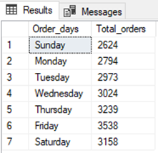

C. Monthly Trend for Orders:
1. Create a line chart that illustrates the hourly trend of total orders throughout the day. The chart will allow us to identify peak hours or periods of high order activity.
SELECT DATENAME(MONTH, order_date) as Month_names, COUNT(DISTINCT order_id) as Total_orders
FROM pizza_sales
GROUP BY DATENAME(MONTH, order_date)
ORDER BY Total_orders DESC
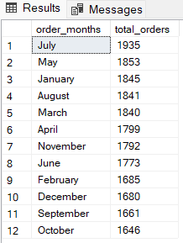

D. Percentage of Sales by Pizza categories:
1. Create a pie chart that shows the distribution of sales across different pizza categories. This chart will provide insights into the popularity of various pizza categories and their contributions to overall sales.
SELECT pizza_category, SUM(total_price) AS Total_Sales, SUM(total_price) * 100 / (SELECT SUM(total_price) FROM pizza_sales)
AS Perctg_Sales
FROM pizza_sales
GROUP BY pizza_category

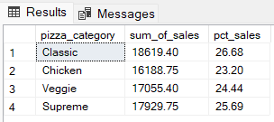
** In order to filter this data according to each month:
SELECT pizza_category, CAST (SUM(total_price) AS DECIMAL (10,2)) AS Total_Sales, CAST (SUM(total_price) * 100 /
(SELECT SUM(total_price) FROM pizza_sales WHERE MONTH(order_date) = 1) AS DECIMAL (10,2))
AS Perctg_Sales
FROM pizza_sales
WHERE MONTH(order_date) = 1
GROUP BY pizza_category

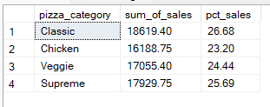

E. Percentage of Sales by Pizza sizes:
1. Generate a pie chart that represents the percentage of sales attributed to different pizza sizes. This chart will us to understand customer’s preferences for pizza sizes and their impact on sales.
SELECT pizza_size, CAST(SUM(total_price) AS DECIMAL (10,2)) AS Total_Revenue,
CAST (SUM (total_price) * 100 /
(SELECT SUM (total_price) FROM pizza_sales)AS DECIMAL (10,2)) AS Perctg_Sales
FROM pizza_sales
GROUP BY pizza_size
ORDER BY pizza_size

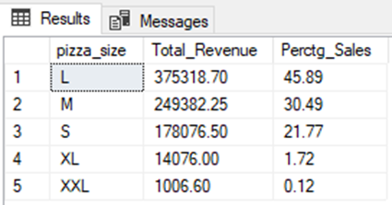

F. Total Pizza Sold by Pizza Catagory:
1. Create a funnel chart that represents the total number of pizza sold for each pizza category. This chart will allow us to compare the sales performance of different pizza categories.
SELECT pizza_category, SUM (quantity) AS Total_Qty_Sold
FROM pizza_sales
GROUP BY pizza_category
ORDER BY pizza_category

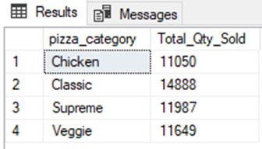

G. Top 5 best seller by Revenue, Total quantity and Total orders:
1. Create a bar chart highlighting the top 5 bestselling pizzas based on the revenue, total quantity, total orders. This chart will help us to identify the most popular pizza options.
(i) Top 5 category of pizzas w.r.t Revenue
SELECT TOP 5 pizza_name, CAST(SUM(total_price) AS DECIMAL(10,3)) AS Total_Revenue
FROM pizza_sales
GROUP BY pizza_name
ORDER BY Total_Revenue DESC
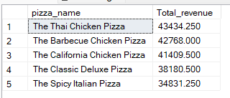

(ii) Top 5 category of pizzas w.r.t Quantity
SELECT TOP 5 pizza_name, CAST(SUM(quantity) AS DECIMAL(10,3)) AS Total_Quantity
FROM pizza_sales
GROUP BY pizza_name
ORDER BY Total_Quantity DESC
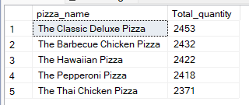
(iii) Top 5 category of pizzas w.r.t Orders
SELECT TOP 5 pizza_name, COUNT(DISTINCT order_id) AS Total_Orders
FROM pizza_sale
GROUP BY pizza_name
ORDER BY Total_Orders DESC
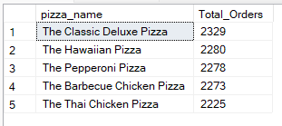

H. Bottom 5 best seller by Revenue, Total quantity and Total orders:
1. Create a bar chart highlighting the top 5 bestselling pizzas based on the revenue, total quantity, total orders. This chart will help us to identify the most popular pizza options.
(i) Top 5 category of pizzas w.r.t Revenue
SELECT TOP 5 pizza_name, CAST(SUM(total_price) AS DECIMAL(10,3)) AS Total_Revenue
FROM pizza sales
GROUP BY pizza_name
ORDER BY Total_Revenue ASC
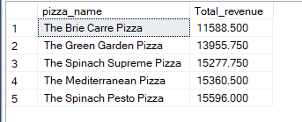

(ii) Top 5 category of pizzas w.r.t Quantity
SELECT TOP 5 pizza_name, CAST(SUM(quantity) AS DECIMAL(10,3)) AS Total_Quantity
FROM pizza_sales
GROUP BY pizza_name
ORDER BY Total_Quantity ASC
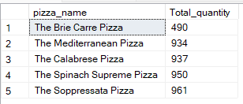
(iii) Top 5 category of pizzas w.r.t Orders
SELECT TOP 5 pizza_name, COUNT(DISTINCT order_id) AS Total_Orders
FROM pizza_sales
GROUP BY pizza_name
ORDER BY Total_Orders
